SUMMARY OF VERB TIME TENSES IN ENGLISH 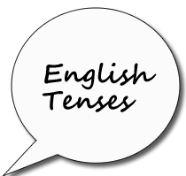
I) Present tense:
1-Simple present: They rarely lose their temper. He travels a lot.
2- Present continuous: They are collecting new data.
II) Past tenses
1- Simple past (2nd column): Peter lived in China in 1965. 2- Past continuous: I was reading when she arrived.
III) Perfect tenses (have/has/had +p.p. (3rd column)
1- Present Perfect: I have worked hard.
2- Present perfect continuous: They have been investigating this for years
3- Past perfect: He had talked to her several times.
4- Past perfect continuous: He had been talking to her at school
5- Future perfect: We will have arrived in the States by the time you get this letter.
IV) Future tenses = ( will + v = em português --REI )
1- Simple future: They will go to Italy next week.
2- Future continuous: I will be traveling by train.
3- Future – going to (immediate) - She is going to leave.
V) Conditional tenses (would + v = em português --RIA)
1- Present conditional: If he had the money he would go.
2- Present continuous conditional: He would be getting up now if he was at home.
3- Perfect conditional: She would have visited me if she had had time.

